# Extracting month from date

select *,month(InvoiceDate)as month from orders;

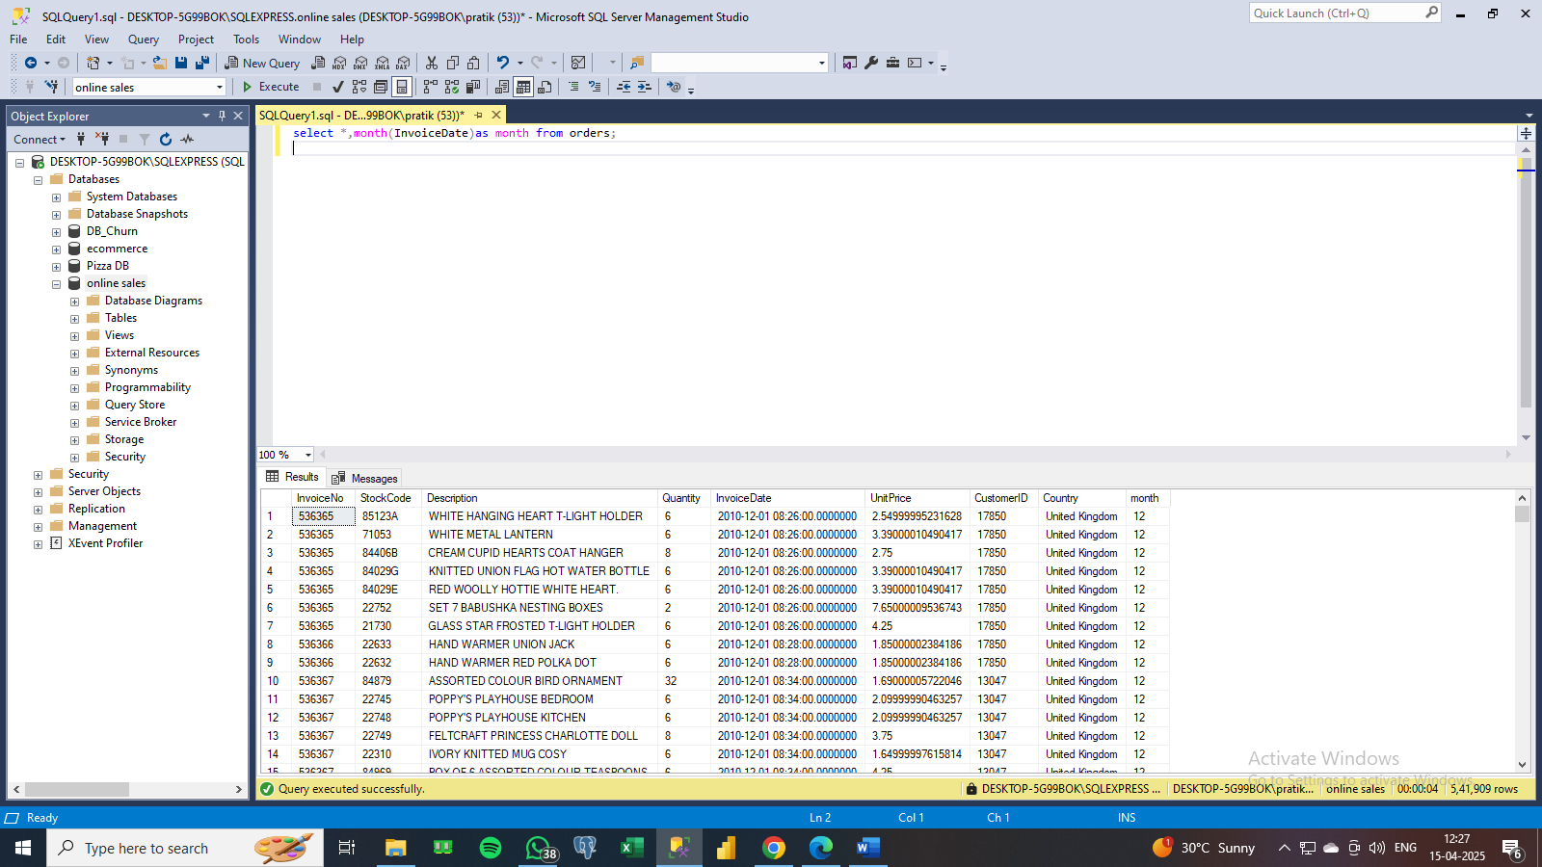

# Find the customer id of the top spender

select sum(unitprice)as total_bill,CustomerID from orders

where CustomerID is not null

group by CustomerID

order by 1 desc

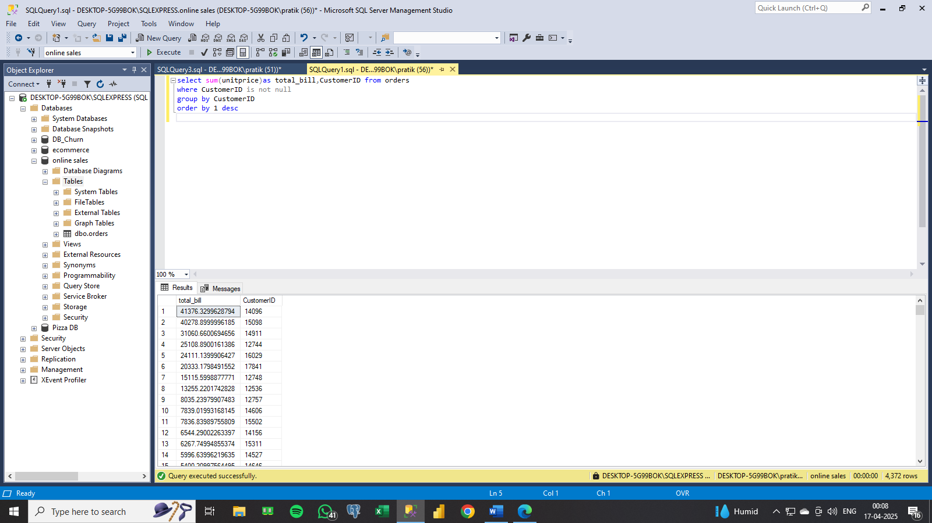

# Find the revenue

select sum

(unitprice*quantity)

as revenue

from orders

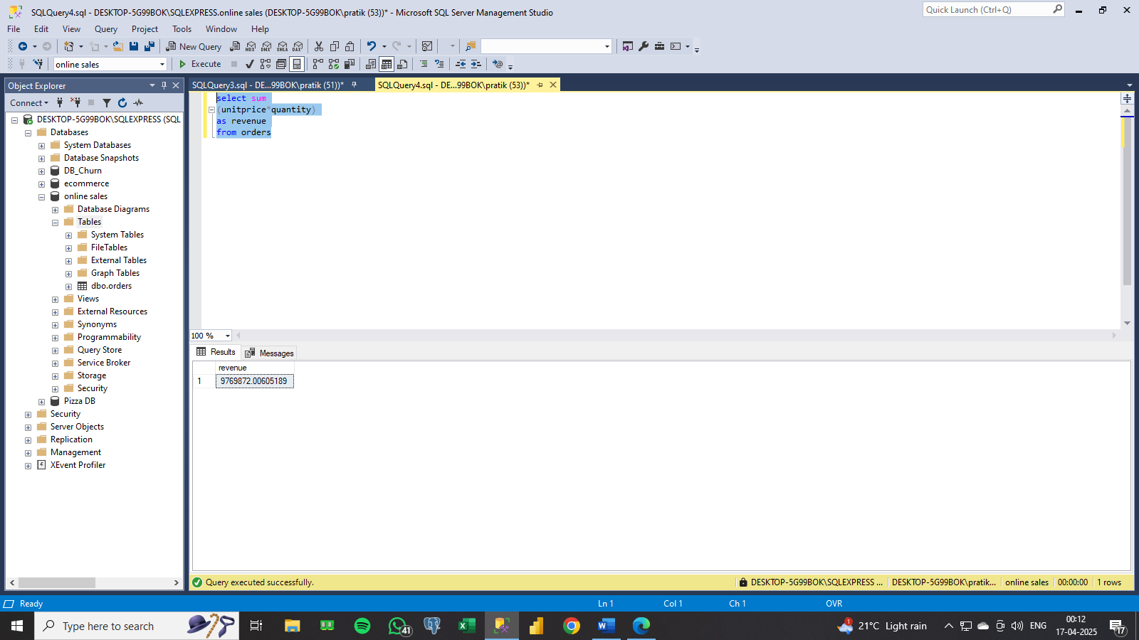

# Find the top 3 spending country

select top 3

sum(unitprice)as total_bill,CustomerID,Country

from orders

where CustomerID is not null

group by CustomerID,Country

order by 1 desc

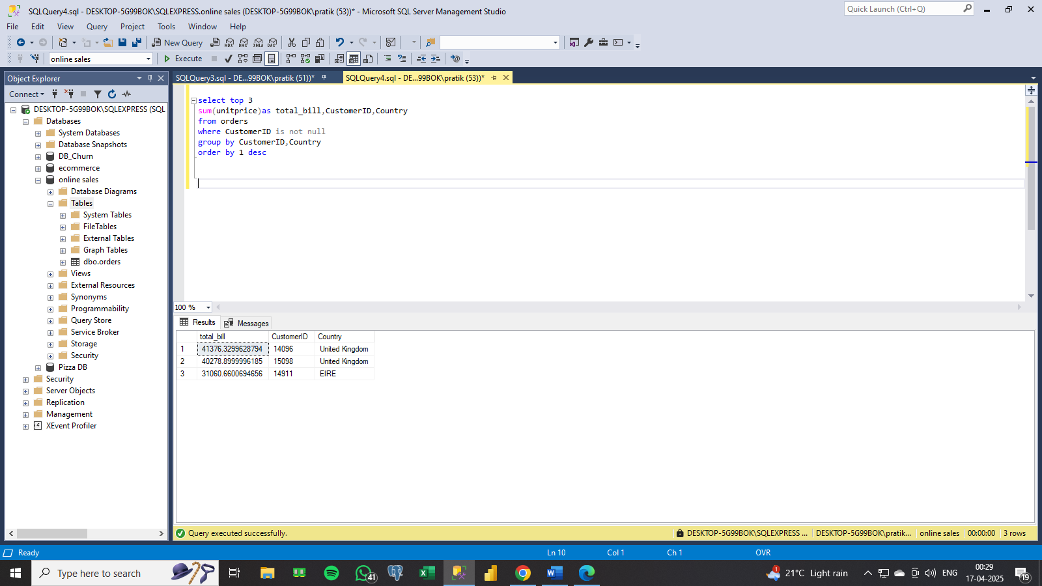

# Find the total quantity

select sum

(quantity)

as total_quantity

from orders

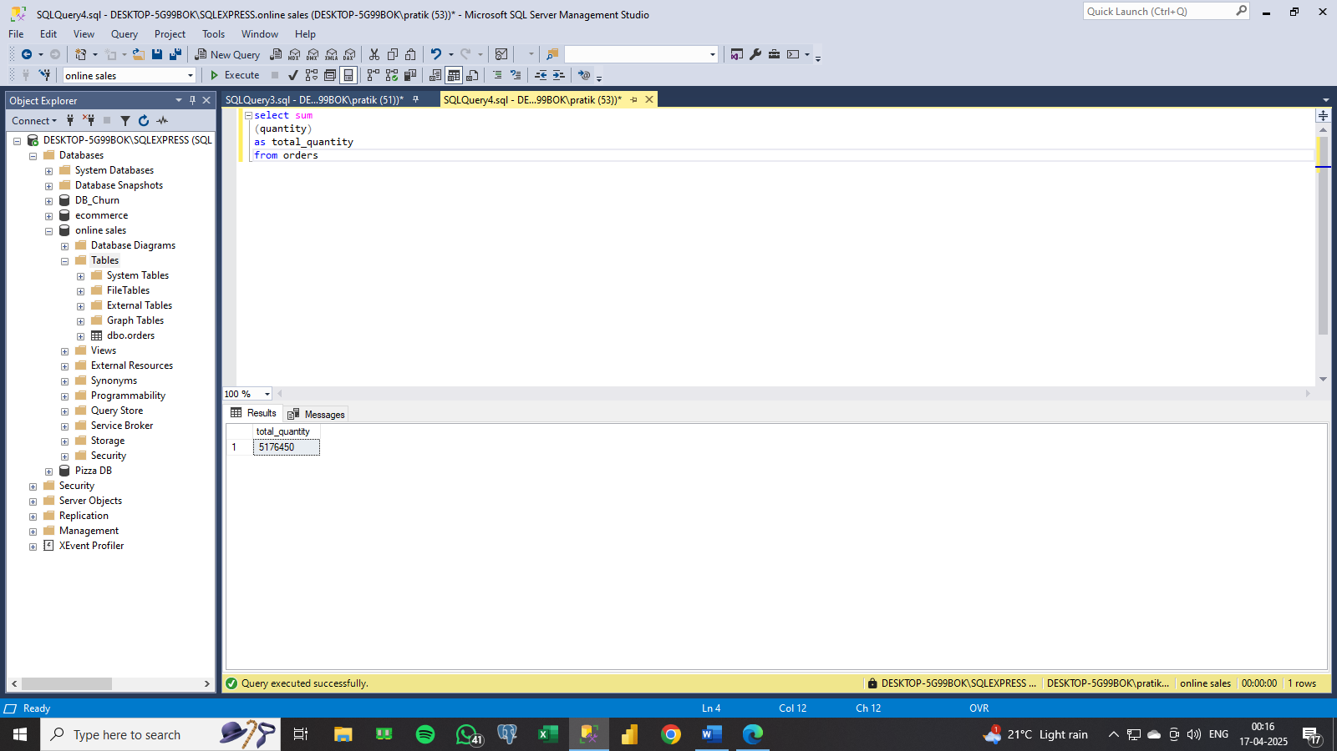

# Count total number of orders

select count(distinct invoiceno)as total_orders

from orders

